Programming is no longer just about writing code manually. Modern developers work alongside AI tools, cloud systems, data pipelines, and automation platforms every day.
But regardless of how advanced these tools become, the engineer still needs to understand how systems work, how to solve problems logically, and how to communicate instructions clearly enough for machines to execute them correctly.
This lesson introduces the foundational ideas behind programming and explains why programming literacy remains one of the most valuable skills for anyone working in software, data science, or AI-driven systems.
By the end of this lesson, you should be able to:
- Define programming and explain how it enables humans to communicate instructions to computers
- Identify real-world applications of programming that are specific to data science and data engineering work
- Articulate why programming literacy matters for data professionals — including in an era of AI-assisted coding
- Describe the role of programming within the broader field of computer science

Before we define it formally, consider this: the content you are reading right now, every word, every layout decision, every interactive element in this course, exists on your screen because someone wrote code that put it there. The LMS platform rendering this page, the database storing your progress, the logic that will mark this lesson complete when you finish it, all of it is programmed.
Programming is the process of writing instructions that a computer can understand and execute. Those instructions tell the machine what to do, in what order, and under what conditions. The result is a program: a structured set of commands that, when run, produces a desired outcome.
As a data professional, you will encounter this in very practical terms:
- A Python script that reads a raw CSV file, cleans it, and loads it into a database
- A SQL query that filters millions of rows to surface the three records that matter
- A Jupyter Notebook that trains a model and outputs a confusion matrix
- An automated pipeline that runs every night and alerts your team if something breaks
Every one of these is a program. You wrote instructions. A machine followed them.

Programming in the Age of AI
Some of the instructions you give are classical code written in a programming language with strict syntax. Others are prompts given to an AI system that generates code or performs actions on your behalf.
Either way, programming is fundamentally an act of communication: expressing intent clearly enough that a machine can act on it.
Someone still must direct the tools, evaluate the output, and own the result. That someone is you.
Programming in the Context of Computer Science
Concept | What it does | Where you will encounter it
Algorithms | The step-by-step logical blueprint for solving a problem | Sorting data, training models, building search functions
Data structures | How information is organized and stored for efficient use | Lists, dictionaries, DataFrames, database tables
Programming languages | The syntax and rules through which ideas are expressed | Python, SQL, R, Scala, Bash
Compilers / interpreters / runtimes | Translate code into instructions the hardware can execute | Python interpreter, Jupyter kernel, cloud execution environments
AI models | A newer layer that can generate code, interpret natural language, and produce outputs classical code alone could not | GitHub Copilot, Claude, ChatGPT used as coding assistants
Computer science is the study of computation, how problems can be solved through systematic processes and how those processes can be automated. Programming is the practical expression of that study. It is how theoretical ideas become working systems.

Inside computer science, programming sits at the intersection of several foundational ideas:
Programming is the thread that ties all of these together. Without it, algorithms stay abstract, data structures stay theoretical, and AI models stay disconnected from the systems they are meant to power.
With programming, all of these become working software, and working data products.

What Programming Actually Looks Like
A program begins as a problem. The journey from problem to working software follows roughly the same shape regardless of the tools you use.
Explore the Programming Workflow
1. Analysis
Understand what needs to be solved. A stakeholder might ask for "a dashboard," but what they need is a reliable data pipeline, a clear metric definition, and a single chart. Defining the right problem is still entirely a human responsibility.

2. Design
Decide which approach to take: which algorithms to use, how to structure the data, where classical code belongs, and where AI tools might fit into the solution.

3. Writing the code
Express the solution in a programming language. Today, much of this happens in collaboration with AI tools that can scaffold functions, suggest implementations, and explain unfamiliar syntax.
Your role is to direct the process, evaluate what is produced, and ensure the pieces fit together correctly.

4. Testing and debugging
Run the code against real data and edge cases. It will break somewhere.
Tracing failure, understanding the cause, and fixing it is where engineering depth becomes visible.

5. Refinement
Improve the program until it works correctly, efficiently, and reliably for the people and systems that depend on it.
Remember:
Programming is not about memorizing syntax.
It is about logical thinking, attention to detail, breaking complex problems into smaller pieces, and developing the judgment to know when an AI-generated solution is good enough and when it is not, and the persistence to work through errors and surprises.
Programming in Data Science vs Data Engineering
Both data scientists and data engineers use programming as their core tool, but the emphasis differs.
Understanding the distinction will help you prioritise your learning as you build your technical foundation.
 | Data Science | Data Engineering
Primary goal | Extract insight from data | Build and maintain data infrastructure
Typical tasks | Data cleaning, statistical modelling, machine learning, visualization | ETL pipelines, database design, API development, orchestration
Common languages | Python, R, SQL | Python, SQL, Scala, Bash, Java
Key tools | Jupyter, Pandas, Scikit-learn, Matplotlib | Airflow, Spark, dbt, cloud platforms (AWS, GCP, Azure)
Programming focus | Analysis scripts, model training, experiment tracking | Scalable, reliable, automated data systems

In practice, these roles overlap. A data scientist who cannot write reliable pipelines is limited. A data engineer who cannot read model code is flying blind.
This programme builds foundational programming competence that supports both paths.
Why Learn Programming as a Data Professional?
You may have heard the argument that AI can now write code, so why spend time learning to write it yourself?
Here is the honest answer:

Key Insight
Learning to programme matters more now than it did before.
Programming is no longer just about producing code. It is about thinking clearly enough to use powerful tools effectively.
Problem-solving and analytical thinking
Programming teaches you to break problems apart, think systematically, design solutions, and reason about trade-offs.
When a data pipeline produces incorrect numbers or a production workflow breaks, these habits are what help you diagnose and fix the issue.

Career opportunities and competitive advantages
Programming skills remain in demand across every industry and continue to provide strong career opportunities.
More importantly, engineers who understand software deeply, and who can direct AI systems effectively, will have a major advantage over those who only rely on tools without understanding the systems underneath.

Creativity and autonomy
Programming gives you the ability to automate repetitive work, build your own tools, and bring ideas into the world without waiting for someone else to build them for you.
AI amplifies this ability dramatically.
Adaptability
The frameworks and tools you use today may not be the same ones you use in three years.
What remains valuable is the underlying way of thinking: logical decomposition, abstraction, iteration, debugging, and systems reasoning.
Key Takeaways
- Programming is communication. You are expressing intent clearly enough that a machine can act on it.
- Programming is practical computer science. It transforms theoretical ideas into working systems and data products.
- Writing good programmes requires more than syntax. Logical thinking, design, and problem-solving matter even more in the AI era.
- Programming is foundational to every modern data and software role.

- Computers need precise instructions. Programming languages provide a structured way to communicate with machines
- Your code passes through a translation process before the computer can execute it
- Programs execute sequentially, meaning the order of instructions directly affects the outcome
- Programming languages are tools, and different languages are designed for different kinds of tasks
A program is a precise set of instructions
A program is a precise, ordered set of instructions that tells a computer what to do, step by step. Every program ever written, from a two-line script that renames files to a machine learning model processing millions of data points, follows this same definition.
The key word is precise. Unlike instructions given to a person, instructions for a computer leave no room for interpretation. A person asked to “clean up the spreadsheet” can use judgement to figure out what that means. A computer cannot. Every step must be explicit, unambiguous, and complete.
Think of it like a recipe:
- The ingredients are your data — the raw material the program works with.
- The steps are your logic — the instructions that transform the data.
- The finished dish is your output — the result the program produces.
Change the ingredients, and you get a different result. Skip a step, and the dish fails. The same is true of a program.
Every program follows one fundamental rhythm
Regardless of complexity, every program operates on the same underlying cycle:
INPUT → PROCESS → OUTPUT
- Input is the data or information the program receives — a file, a number typed by a user, a row from a database, or a signal from a sensor.
- Process is the logic the program applies to that input — calculations, comparisons, transformations, and decisions.
- Output is what the program produces as a result — a number, a file, a chart, a prediction, or an alert.
This is not a simplification. It is the actual structure of every program you will write as a data professional.

Scenario | Input | Process | Output
Data cleaning script | Raw CSV with missing values | Identify and fill or remove nulls | Clean CSV ready for analysis
Sales dashboard | Monthly transaction records | Aggregate by region and calculate totals | Summary table and chart
Fraud detection model | A new transaction | Compare against patterns from historical data | “Flagged” or “Not flagged”
Automated pipeline | New files landing in a folder | Transform and load into a database | Updated database table

Every one of these is a program. Every one follows input → process → output.
Programs must be planned before they are written
Here is something that surprises many beginners: experienced programmers do not start by opening a code editor. They start by thinking through the logic of the program in plain language before touching any syntax.
Why? Because code is just the expression of a plan. If the plan is unclear, the code will be unclear. If the plan is wrong, the code will be wrong — and a wrong program that runs without errors is harder to fix than a program that simply does not run.
A useful habit is to write your program’s logic in plain English first:
1. Open the sales data file
2. For each row, check whether the revenue column is empty
3. If it is empty, flag that row for review
4. If it is not empty, keep the row as-is
5. Save the flagged rows to a separate file
6. Count and display how many rows were flagged
This plain-English description is a complete program — it has a clear input, defined processing steps, and a specific output. Writing actual code from this point is a matter of translating each step into Python syntax. Without this plan, writing the code is guesswork.
Planning before coding
You will build on this planning skill in the next module — Introduction to Programming II — where you will work with formal planning tools like pseudocode and flowcharts.
For now, the habit of thinking through logic before writing code is the foundation.
Reflect:
Think of a repetitive task in your current work or studies — something you do manually and regularly.
Write the input → process → output structure for a program that could automate it:
- Input: What data or information would the program need?
- Process: What steps would it follow? List them in order, in plain English.
- Output: What would it produce when finished?
You do not need to know how to write the code yet. The goal is to practice thinking like a programmer — precisely, sequentially, and with a clear outcome in mind.
What is a Programming Language?
Programming languages are the tools engineers use to communicate with computers. Different languages exist because different problems require different trade-offs — speed, readability, scalability, statistical analysis, automation, or system control.
As a data professional, you do not need to master every language. What matters is understanding what languages are designed to do, why certain languages dominate certain fields, and how to choose the right tool for the task at hand.
Why so many languages?
If programming is essentially about giving instructions to a computer, why does the world need hundreds of different languages to do it?
The answer is trade-offs. Every programming language was designed to solve a specific set of problems better than what existed at the time. Some prioritize speed of execution. Others prioritize how quickly a developer can write and test code. Some are built for a specific domain — like querying databases. Others are general-purpose tools that work across many contexts.
There is no single best language. There is only the right language for the job at hand. As a data professional, understanding this principle is more valuable than memorizing any specific syntax — because the language you use will change depending on what you are building, where you are working, and what your team already knows.
What a programming language actually is
A programming language is a formal system of rules and meanings that lets humans write instructions a computer can understand and execute.
Every language has two essential dimensions:
Syntax defines what is valid to write — the grammar rules of the language. If you break syntax rules, the computer will not be able to read your code and will return an error immediately. This is actually helpful: syntax errors are caught quickly and are usually straightforward to fix.
Semantics defines what that valid code really means — what it will do when it runs. Semantic errors are more dangerous because your code may run without any error message but produce the wrong result. A data cleaning script that runs to completion but silently drops valid rows has a semantic problem, not a syntax problem.
The languages that matter for data work
As a data professional, you will not need to learn every language. You will work primarily within a focused ecosystem.
Here is what that ecosystem looks like and why each language exists within it.
Language | What is it used for | Why it matters to you
Python | Data analysis, machine learning, automation, pipelines, APIs | The primary language of this programme and the data field. Readable, versatile, and backed by the most extensive data science library ecosystem in existence.
SQL | Querying and transforming data in relational databases | You will use SQL constantly. Every database interaction — filtering, aggregating, and joining tables — happens in SQL.
R | Statistical computing and data visualization | Widely used in academic and research contexts. Some teams use it alongside Python.
Bash / Shell | Automating system tasks, running scripts, managing files and pipelines | Essential for data engineers who work in cloud and Linux environments.
Scala | Big data processing, particularly with Apache Spark | Used in data engineering at organizations working with very large data volumes.

This list is not exhaustive — you may encounter others as your career develops. But these are the languages that will appear most frequently in your work, and Python and SQL are the two you will use from day one.
Why Python?
Three things explain Python’s dominance in the data field:
Readability. Python code reads closer to plain English than almost any other language. This matters enormously when you are learning, when you are collaborating with colleagues, and when you return to code you wrote six months ago and need to understand it quickly.
The library ecosystem. Python’s data science libraries — NumPy for numerical computing, Pandas for data manipulation, Matplotlib and Seaborn for visualization, and Scikit-learn for machine learning — are mature, well-documented, and widely supported. You do not build these tools from scratch; you use them.
The community. Python has one of the largest and most active programming communities in the world. Whatever problem you encounter, someone has already encountered it, written about it, and shared the solution. This dramatically reduces the time you spend stuck.
The Building Blocks
Every programming language — from Python to SQL to Bash — is built from the same small set of foundational components.
Expand each section below to explore the core building blocks that appear across all programming languages.
- Syntax
Syntax is the grammar of a programming language.
It defines how code must be written, including punctuation, structure, spacing, and formatting rules.
If syntax rules are broken, the program cannot execute.
- Syntax errors are usually caught immediately
- Error messages often point directly to the problem
- These are usually the easiest programming errors to fix

- Semantics
Semantics refers to the meaning behind the code.
Syntax determines whether code is written correctly. Semantics determines what the code actually does.
A program may run successfully while still producing incorrect results.
- Syntax errors stop execution
- Semantic errors produce incorrect logic or outputs
- Semantic issues are often harder to detect
- Data types
Data types define the categories of values a language can work with.
Examples include numbers, text, true/false values, and collections of data.
Data types determine which operations are valid.
- Numbers can be added together
- Text values can be combined
- Certain operations fail when types are incompatible
- Operators
Operators are symbols that perform actions on data.
They are used for calculations, comparisons, and assigning values.
Operators drive most transformations inside programs.
- Arithmetic calculations
- Comparing values
- Storing results in variables
- Control flow
Control flow allows programs to make decisions and repeat actions.
Programs do not always execute from top to bottom in a straight line.
Control flow enables logic such as:
- If this condition is true, do this
- Otherwise, do something else
- Repeat this action until the condition changes
This gives programs flexibility and decision-making ability.
- Functions
Functions group reusable logic into a single named block.
Instead of rewriting the same steps repeatedly, programmers create functions that can be reused whenever needed.
Functions help programs remain:
- Organised
- Readable
- Maintainable
They are essential for building larger systems efficiently.
- Standard library
The standard library is the collection of built-in tools included with a programming language.
It provides ready-made solutions for common tasks.
- Working with files
- Processing text
- Performing calculations
- Handling dates and times
Using standard libraries saves programmers from rebuilding common functionality from scratch.
- Runtime environment
The runtime environment is what executes your code.
It handles:
- Running programs
- Managing memory
- Handling errors
- Connecting code to the operating system and hardware
The runtime environment acts as the bridge between written code and the computer itself.

High Level vs Low Level Programming Languages
Not all programming languages operate at the same distance from the computer. Some languages stay extremely close to the hardware and provide precise control over how a machine operates, while others prioritize readability, productivity, and human understanding.
In this lesson, you will explore the spectrum between low-level and high-level programming languages, understand where Python sits on that spectrum, and see why this matters for modern data science and data engineering work.
Why This Spectrum Exists
So far, you have learned that computers only understand one thing at the hardware level: binary - sequences of 1s and 0s. Every action performed by a computer ultimately reduces to electrical signals processed by circuits.
Programming languages exist to bridge the gap between that machine-level reality and the way humans naturally think and communicate. But not every language bridges that gap in the same way.
Some languages stay very close to the machine itself. Others prioritize human readability and abstract away the hardware entirely. This difference creates the spectrum between low-level and high-level programming languages.
Key Idea
The closer a language is to the machine, the more control and performance it provides. The closer it is to human language, the easier it becomes to read, write, and work productively.

Category | Low-level Languages | High-level Languages
Closeness to hardware | Very close — mirrors how the machine operates | Far from hardware — abstracts hardware details away
Readability | Difficult — requires deep hardware knowledge | Easy — reads closer to natural language
Control | Very precise — programmer manages almost everything | Less direct control — many details handled automatically
Speed of execution | Very fast — minimal translation required | Slightly slower — additional translation layers exist
Speed of development | Slow — every detail must be specified manually | Fast — developers focus on logic instead of mechanics
Examples | Assembly, C | Python, SQL, R, JavaScript

Neither side of the spectrum is inherently better. They are optimised for different purposes. The central trade-off is always the same: control and performance versus readability and productivity.
Where Python Sits - And Why It Matters for Data Work
Python sits firmly on the high-level side of the spectrum. This is a deliberate design choice and one of the reasons Python became the dominant language for data science and data engineering. When you write Python code:
- You do not manually manage memory allocation
- You do not work directly with processor registers
- You do not specify how data should be stored in hardware memory
Python handles those details automatically. This allows you to focus on:
- The data you are working with
- The transformations you need to perform
- The outputs and insights you want to produce

This abstraction has several major advantages for data professionals:
- You move faster
Tasks that would take hours in a low-level language can often be completed in minutes using Python. This rapid iteration is essential during:
  - Data exploration
  - Cleaning messy datasets
  - Building models
  - Testing ideas quickly
- Your code is readable
Python code written clearly often reads similarly to plain English. This improves collaboration because:
  - Team members can understand each other's work more easily
  - Stakeholders can follow the logic behind analyses
  - You can revisit old code months later and still understand it
- You work at the level of data, not hardware
Python allows you to focus on:
  - Data transformations
  - Machine learning workflows
  - Automation
  - Pipeline logic
Instead of worrying about memory addresses and machine instructions, you work directly with the ideas relevant to your role.
Why Low-level Languages Still Matter
As a data professional, you are unlikely to write low-level code yourself. However, you will constantly experience its effects. Understanding this makes you a much stronger problem-solver.

The Libraries You Use Depend on Low-level Code
Many of Python's most important data libraries are implemented using lower-level languages such as C and Fortran.
This includes:
- NumPy
- Pandas
- Scikit-learn
When you perform operations across millions of data points, the heavy computation often runs in compiled low-level code underneath Python.

Python provides the readable interface.
Low-level languages provide performance.
Performance Differences Have Causes
Sometimes operations written purely in Python run slowly compared to vectorized operations in NumPy or Pandas.
This is because:
- Pure Python loops execute at Python speed
- Vectorized library operations are carried out in compiled low-level code
Understanding this distinction helps you reason about optimization and performance bottlenecks.
The Abstraction Ladder Is Real
Every high-level operation you perform depends on many lower layers underneath it.
For example, a single Pandas operation may involve:
- Your Python code
- The Pandas library
- NumPy
- Compiled C code
- Machine instructions executed by the processor
This layered abstraction allows you to work productively without needing to think about the lower levels directly.
At the same time, understanding that these layers exist helps you reason about what is possible, what is fast, and where system limitations come from.

Spectrum at a Glance
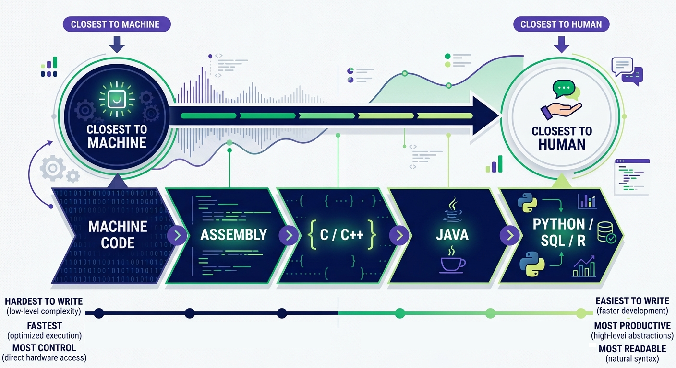Spectrum of Programming Languages.

Python and SQL sit toward the high-level end of the spectrum.
That is exactly where data professionals need to operate — focusing on ideas, logic, and outcomes instead of hardware mechanics.
Key Takeaways
- Programming languages exist on a spectrum. Low-level languages prioritize performance and control, while high-level languages prioritize readability and productivity.
- Python is high-level by design. It abstracts away hardware complexity so data professionals can focus on logic, analysis, and outcomes.
- You will regularly experience the effects of low-level code through the libraries and tools that power Python's performance.
- The abstraction ladder works in your favour. High-level languages let you operate at the level that matters for your role while lower layers handle the underlying computation.

Runtime Environments and How Code Executes
Writing code is only one part of programming. Every program also needs an environment where it can run, access memory, load libraries, execute instructions, and produce results. Understanding that environment is essential for working effectively with Python, Jupyter Notebooks, and modern cloud-based development platforms.
In this lesson, you will explore how runtime environments work, how Jupyter Notebooks execute code through a live Python kernel, and how cloud-based systems provide the infrastructure that allows your programs to run consistently and reliably.
Bringing the Knowledge Together
Across this module you have built a conceptual foundation: what programming is, how programs are structured, what languages look like and how they differ, and where Python sits in the broader landscape.
This lesson makes that foundation practical. Before you write your first line of Python code, you need to understand the environment in which that code will live and run.
What is a Runtime Environment?
You have learned that high-level languages like Python require a translation layer — something that converts your readable code into instructions the machine can execute.
That translation layer does not operate in isolation. It needs memory, access to libraries, error handling systems, and communication with the operating system beneath it.
That surrounding infrastructure is the runtime environment.
Think of it as the workshop where your code comes to life. A carpenter needs more than wood and tools — they also need a workbench, lighting, and a properly organised workspace. A runtime environment plays the same role for software.
For Python specifically, the runtime environment includes:
- The Python interpreter — the program that reads and executes Python code
- The Python standard library — built-in tools for common tasks such as file handling, mathematics, and working with dates
- Installed packages — additional libraries like Pandas or NumPy that extend Python's capabilities
- Memory and system resources — allocated by the operating system to the running program
While you can install a data environment locally on your own laptop, modern data professionals rely heavily on cloud-based runtimes.
In the industry, data scientists and engineers use cloud servers to process massive datasets that would crash standard personal computers.
Why Runtime Environments Matter
Your code cannot execute on its own. It depends on interpreters, libraries, memory allocation, and operating system support working together correctly.
Understanding the runtime environment helps you diagnose errors, manage dependencies, and reason about how programs behave beyond the code itself.
Your Working Environment: Jupyter Notebooks
The primary environment you will use throughout this programme is Jupyter Notebook, running on a cloud platform.
You do not need to install anything locally. You simply open your browser, navigate to the platform, and begin working.
A Jupyter Notebook is divided into cells. Each cell can contain either:
- Code — executable Python instructions
- Markdown text — notes, explanations, headings, and documentation
You write code inside a code cell, run it, and the output appears directly below that cell.
This structure matches how data professionals typically work: write a step, run it, inspect the result, adjust, and repeat.
The notebook keeps a visible record of:
- The code you executed
- The outputs produced
- The notes and explanations you added
The Kernel: What Actually Runs Your Code
When you open a Jupyter Notebook, something important starts running in the background: the kernel.
The kernel is a live Python process connected to your notebook.
Every time you run a cell, the notebook sends that code to the kernel for execution. The kernel processes the instructions and returns the results back to the notebook for display.
Understanding the kernel explains several behaviours that often confuse beginners.

Kernel Behaviour | What It Means
State persists across cells | Variables, functions, and data created in one cell remain available in later cells — but only after the defining cell has been executed.  If you try to use a variable before running the cell that creates it, Python will raise an error because the kernel has never seen that variable.
Cell execution order is flexible | Jupyter does not force you to run cells from top to bottom. You can execute cells in any order you choose.  This flexibility is useful, but it can also create confusing situations where the notebook visually suggests one state while the kernel contains another.
Restarting the kernel resets everything | Restarting the kernel clears all variables, functions, and memory from the current session.  After a restart, imported libraries must be loaded again and every required cell must be re-executed.

Anatomy of a Project
A data science project is more than a single notebook. Without clear structure, naming, and version control, it becomes difficult to trace how a result was produced, collaborate with others, or reproduce the same analysis later.
In this lesson, you will look at how professional projects are organized, what kinds of files and folders they typically contain, why naming conventions matter, and how tools such as Git and GitHub support traceable, reliable work.
What is a Project?
In data science, a project is not a single notebook. It is a folder that contains everything required to take an analysis from raw data to a defensible result: the data, the code that transforms it, the notebooks that explore it, the configuration that controls the environment, the documentation that explains the decisions, and any AI artifacts (prompts, model configs, evaluation sets) that shape how the system behaves.
When you open a project in VS Code or JupyterLab, you are opening a folder. Everything inside that folder belongs to the project. This matters because reproducibility — the ability for someone else (or future-you) to run your analysis and get the same numbers — depends almost entirely on whether the project is self-contained and well-organized. It also matters because AI coding assistants read your project. They build context from your file structure, your naming, and the relationships between files. A clean project gives them a clear picture to reason about; a messy one gives them noise.

Files and Folders
The Project Folder
Every project lives in its own dedicated folder — the root of your project. A good habit from day one: one folder per project, a clear and descriptive name, and never mix files from different projects together.
Inside a typical data science project folder, you will find:
- data/ — the datasets the project uses. Often split into data/raw/ (untouched, never edited) and data/processed/ (cleaned, ready for modeling).
- notebooks/ — exploratory Jupyter notebooks (.ipynb) where you investigate the data and prototype ideas.
- src/ — reusable Python modules (.py) extracted from your notebooks once they are stable.
- models/ — saved model artifacts (.pkl, .joblib, .onnx).
- reports/ — final outputs: charts, dashboards, exported PDFs.
- Configuration files — requirements.txt or environment.yml for dependencies, .env for secrets, .gitignore for things Git should skip.
- README.md — a text file that explains what the project does, how to set it up, and how to run it.
- AI-related files — prompts, claude.md / .cursorrules, evaluation data, or instructions that shape how AI tools behave inside the project.

Subfolders
As a project grows, files are grouped into subfolders by purpose. The pattern above — separating data, notebooks, source code, models, and reports — is intentional. It enforces a discipline that makes the analysis easier to reason about: raw data is never edited, code lives in src/, not buried in cells, and outputs are reproducible from the inputs. This structure also communicates the architecture of your work to humans and AI assistants without anyone having to read a single line of code.

File Extensions
A file extension is the suffix at the end of a filename, separated by a dot. It tells the operating system, your editor, and any AI tools you use what kind of file it is and how to handle it. Here are the ones a data scientist will use most often:

Extension | Purpose
.ipynb | Jupyter notebook — your primary workspace for exploration, prototyping, and storytelling with code.
.py | Python source code — reusable functions and modules promoted out of notebooks.
.csv | Comma-separated values — the universal tabular data format.
.parquet | Columnar binary format — faster and smaller than CSV for large datasets.
.json | JSON data or configuration; common output from web APIs.
.md | Markdown — used for README files, project documentation, and prompt files.
.yml / .yaml | Configuration — conda environments, pipeline definitions, CI configs.
.env | Environment variables and secrets (API keys, database URLs). Never commit this to Git.
.pkl / .joblib | Serialized Python objects — typically trained models or fitted preprocessing pipelines.
.sql | SQL queries — saved separately so they are reviewable and reusable.

Your IDE uses the extension to apply syntax highlighting and run the right tools. AI assistants use it to decide what kind of help to offer. Naming files correctly is not cosmetic — it changes what your tools can do for you.

Version Control: Git and GitHub
A project folder on your laptop is private and fragile. The moment you want to share an analysis, collaborate with a teammate, or recover an older version of a notebook, you need version control. The standard tool is Git, and the standard place to host Git repositories online is GitHub.
Git tracks every change you make: which lines were added, which were removed, when, and (if you write good commit messages) why. For a data scientist this is invaluable — when a chart changes from one week to the next, Git can tell you exactly which commit changed the data cleaning logic.
Why Project Organization Matters
A disorganized data science project is more than untidy — it is a reproducibility risk. When the chart in your final report cannot be traced back to a specific notebook, a specific dataset, and a specific cleaning step, you cannot defend the result. Other analysts need to follow your work, future-you needs to understand it months later, and AI assistants need clean structure to give you useful help. A messy codebase produces messy AI suggestions, and the minutes you save by skipping organization are paid back, with interest, in confusion later.
Good structure is not something you fix at the end. It is a habit you build from the start — the same way a chemist labels every beaker as they work, not afterwards.

What Is White Boarding?
White boarding is a deliberately low-fidelity way of thinking. The tools are crude on purpose — boxes, arrows, scribbled column names, question marks — because the point is to discover the solution, not to document it. The discipline asks you to step away from the keyboard, where syntax constantly competes with thought, and work in a medium where ideas can be rearranged with a single eraser stroke.
A whiteboard session typically produces some mix of:
- A rough data flow — where data comes from and where it ends up.
- A list of inputs the program needs and the outputs it should produce.
- A sketch of the key steps in between, in roughly the right order.
- A short list of edge cases and open questions that need an answer before coding begins.
None of this is code. That is the point.

Why White Board First?
The temptation as a beginner is to start typing immediately. You have a problem, you have a Jupyter notebook open, you start writing import pandas as pd — and within ten minutes you are deep in a chain of .groupby calls without a clear sense of where you are heading. Hours later, you realize the question you were really meant to answer was different.

Flowcharts
Flowcharts turn logic into something you can see. By using standard symbols and arrows, they make it easy to understand how a process moves from one step to the next, where decisions happen, and what outputs should result — before a single line of code is written.

What Is a Flowchart?
A flowchart is a diagram that visually represents a workflow or process using standard symbols and arrows to show the sequence of steps and the decisions between them.
Flowcharts are used across industries to analyse, design, document, and manage processes. In data work, they are particularly useful for sketching the shape of a pipeline — extract, clean, transform, model, evaluate — before any of those steps are implemented. They are equally readable by a senior engineer reviewing your pipeline, a non-technical stakeholder asking what the analysis does, and an AI assistant trying to give you useful implementation suggestions.
Flowchart Symbols
Flowcharts use a standard set of symbols so that anyone familiar with the notation can read your diagram immediately. The widely used standard is ISO 5807. Hover over each shape in the interactive panel below to see what it does.
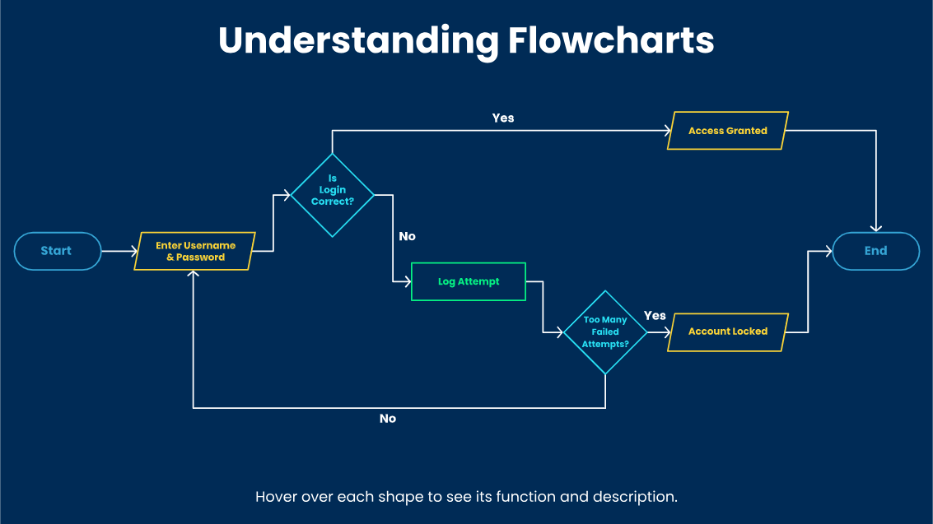
Interactive flowchart symbols and process elements

Pseudocode
Pseudocode helps you think clearly before you worry about syntax. It is a simplified, half-English, half-code description of your program's logic — structured enough to guide implementation, plain enough for a non-coder to follow, and language-independent enough to become Python, SQL, or R without changing a word of the plan.
What Is Pseudocode?
Pseudocode is not code. It has no compiler, no interpreter, and no syntax rules to enforce. It is a structured way of writing down what a program should do, using a mix of plain English and code-like conventions, so the logic is clear before you commit to any language.
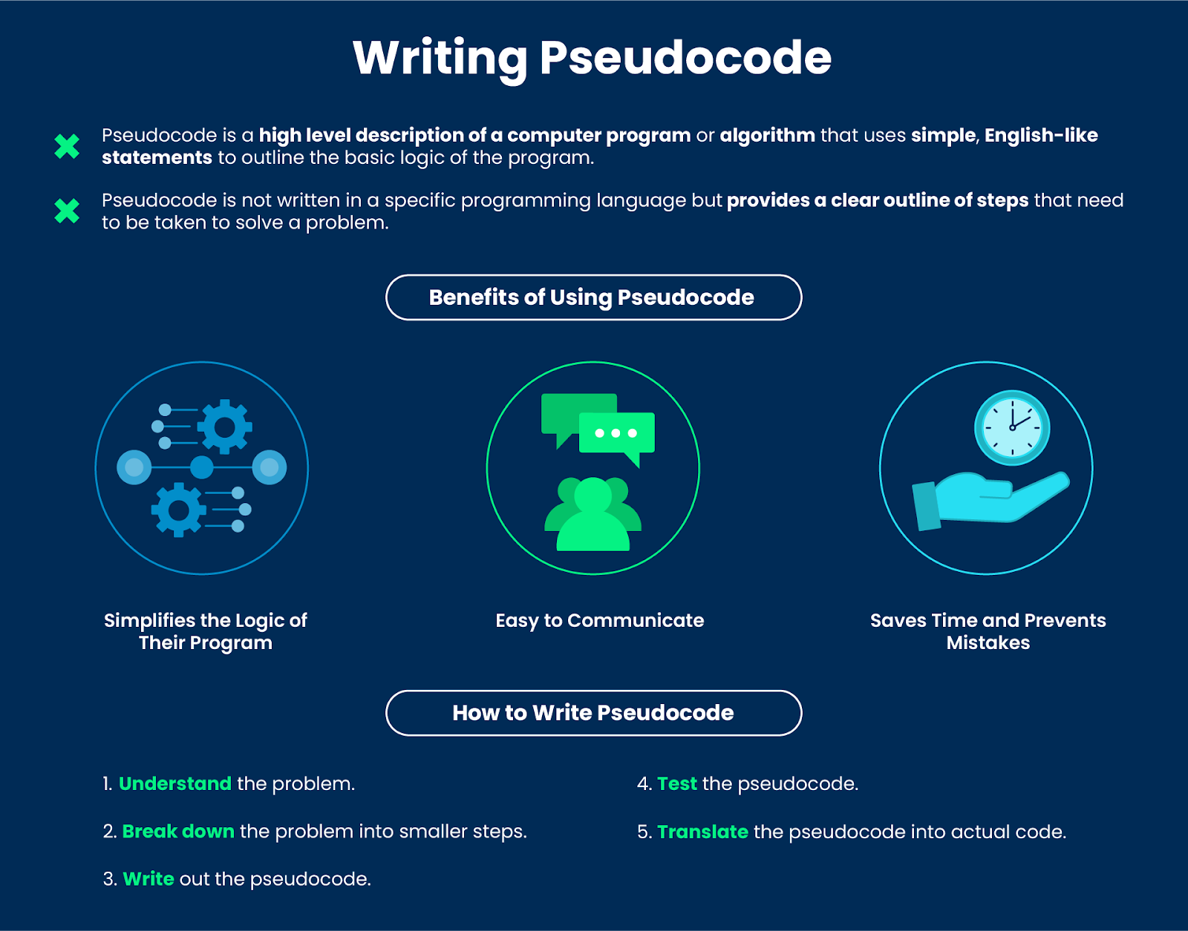

The key characteristics of good pseudocode are:
- Readability — understandable even by someone who does not code.
- Structure — reflects the shape of the code that will be written, but without strict syntax.
- Flexibility — not bound to any specific programming language.
- Brevity — skips implementation details and focuses on high-level logic.

Why Write Pseudocode?
Explore the benefits
- Problem-Solving. It lets you focus on the logic without being distracted by syntax. You can think clearly about what the solution should do before worrying about how any specific language expresses it.
- Communication. Pseudocode is language-neutral. A teammate who works in R, a stakeholder who does not code, and an AI assistant that translates it into pandas can all read the same plan.
- Debugging. Many bugs are bugs in the plan, not in the code. Pseudocode surfaces those early, when they are cheap to fix.
- Language-Independence. The same plan can become Python today, SQL tomorrow, and Spark next quarter. The plan outlives the language choice.
- Edge-Case Discipline. Writing pseudocode forces you to name your edge cases — empty inputs, missing values, divide-by-zero — before they bite you at runtime.
Step-by-step: Writing pseudocode
- Define the goal. State in one sentence what the algorithm should do. If you cannot, you do not understand it yet.
- Identify the main steps. Break the goal into a series of stages in roughly the right order.
- Use capitalised keywords consistently. Stick to a standard set: IF ... THEN ... ELSE ... END IF, FOR EACH ... END FOR, WHILE ... END WHILE, RETURN, FUNCTION.
- Use descriptive names. customer_count, not x. pass_mark, not p.
- Name your edge cases. Empty input, missing values, divide-by-zero — call them out explicitly in the plan rather than hoping the code handles them later.
- Use indentation. Show structure inside loops and conditionals the same way real code does.
- Stay language-independent. Pseudocode that quietly assumes pandas syntax is no longer pseudocode.
Best Practices at a Glance
- Keep it simple. Clear, concise descriptions beat clever ones every time.
- Start small. Break complex problems into smaller pseudocode blocks you can verify independently.
- Review and revise. Treat the first draft as a draft — iterate before implementing.
- Get feedback. A peer or an AI assistant reading your pseudocode will catch issues that someone reading your code might miss, because pseudocode hides nothing in syntax.
- Factor out repeated logic. If a sequence of steps appears more than once, give it a name as a FUNCTION.
- Comment sparingly. Pseudocode should be self-explanatory. Add a comment only to explain why something is done, never what.

Debugging
Imagine assembling furniture and finding that one piece does not fit. You retrace your steps, re-read the instructions, and find the issue. That is debugging: the process of identifying and fixing errors so that your code works as intended. It is not a sign that something went wrong — it is a normal part of programming. The difference between a beginner and an experienced programmer is not that the experienced one makes fewer errors; it is that they find and fix them faster.
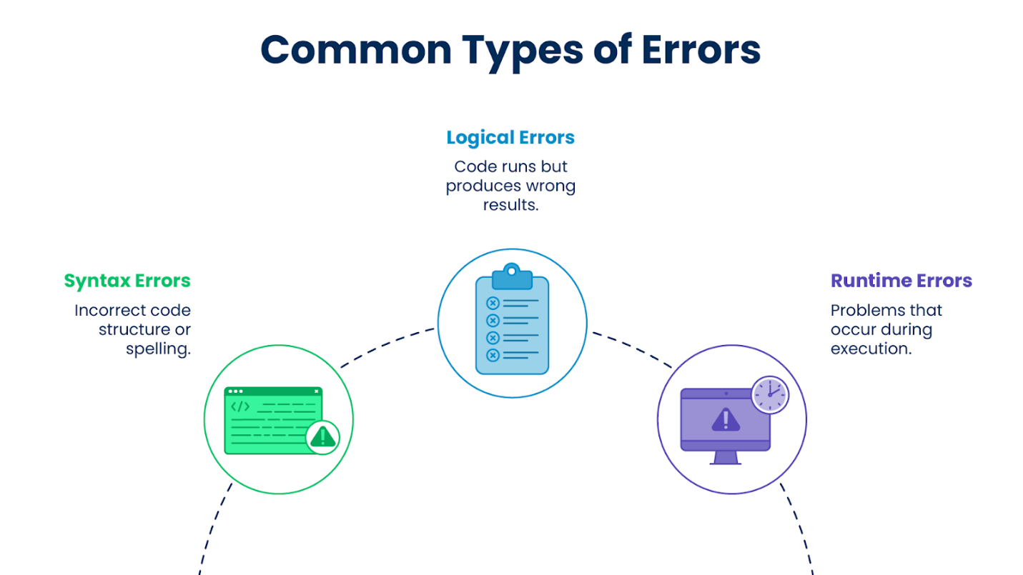

Debugging Strategies
Effective debugging means identifying where things go wrong, understanding why they happen, and making targeted changes to fix them. A few reliable strategies, applied consistently, will turn most bugs from mysteries into routine.
Think Like a Detective
- Read error messages carefully. The first line of the traceback says what went wrong; the last lines say where. Do not skip either.
- Print intermediate values. In a notebook: df.head(), df.shape, df.dtypes, df.info(). Look at the data — do not imagine it.
- Test with different inputs. Especially edge cases: empty inputs, missing values, very large or very small numbers.
- Break complex problems into smaller ones. Comment out parts of a pipeline and run them one at a time until you find the step where the result first goes wrong.
- Set a random seed when randomness is involved (np.random.seed(42), random_state=42) so a bug is reproducible across runs.
Key Takeaways:
- Algorithmic thinking and decomposition are the core of problem-solving in programming. Break every unfamiliar problem into smaller, verifiable steps before writing any code.
- Debugging is a systematic craft, not guesswork. Change one thing at a time; inspect the data at each step; read the error message before doing anything else.
- In data work, most bugs are not random — they cluster around a small set of recurring patterns (wrong dtype, wrong shape, missing values, silent reassignment). Learn to recognise them.
- Print intermediate values early and often. The most common data science bug is "the data is not the shape I thought it was” and the only way to catch it is to look.

Debugging in Practice
Error messages are not interruptions — they are clues. And when code breaks, having a clear process is the difference between a five-minute fix and an hour of frustration. This lesson gives you both: the ability to read what the error is telling you, and a structured process for getting unstuck when reading it is not enough.
Errors Are Part of the Process
Every programmer encounters errors. The senior data scientist with ten years of experience sees more errors per day than the beginner does — they have just learned to read them faster. The mindset shift is small but powerful: an error is not a problem, it is a message.
Important:
You will encounter errors in every language you learn. The specific error names and formats differ between Python, SQL, and JavaScript, but the categories and the approach to reading them are universal. The habits you build here carry forward into every language you use.

What Is an Error Message?
When a program encounters a problem it cannot resolve, it stops and produces an error message. That message typically gives you three things:
- What type of error occurred — a category that describes the nature of the problem.
- What specifically went wrong — a short description of the exact issue, often including the value or name involved.
- Where it happened — the file name and line number where the problem was detected.
These three pieces of information are your starting point for every fix you will ever make. The goal of the sections below is to make each one legible.
The Main Categories of Errors
Syntax Errors
A syntax error occurs when the code breaks the grammar rules of the language. These are caught before the program runs — the interpreter refuses to start. Common culprits: a missing colon, an unclosed parenthesis, or an unmatched quote.
Runtime Errors
A runtime error occurs while the program is running. It started, then failed partway through execution. A common data science example: asking for a column that does not exist on a dataframe.
Logic Errors
The program runs without crashing, but produces incorrect results. These are the most dangerous category in data work because they are silent — your chart still renders, just with the wrong numbers. Catching them requires reasoning, testing, and a healthy mistrust of any result you have not sanity-checked.
Reference and Name Errors
These occur when the program encounters a name it does not recognize — often a typo, an undefined variable, or a variable used before it was assigned.
Type Errors
These occur when an operation is applied to the wrong type of value — adding a string to a number, or calling a numeric operation on a column whose dtype is object.
Import Errors
These occur when a required package or module cannot be found. Often the package is not installed in the environment your notebook is using — a common Jupyter trap, since the kernel and the terminal can be in different environments.

Errors a Data Scientist Will See Every Week
The categories above are general. In day-to-day data work, a handful of specific errors appear so often they are worth recognizing on sight. When you see them, you should already know the likely cause before you have read the full message.
Common Python / pandas Errors and What They Usually Mean
KeyError: 'customer_id'
You asked for a column that does not exist. Check the spelling, check for trailing spaces ('customer_id ' with a space is a different key), and verify you loaded the right file.
ValueError: could not convert string to float: '1,200.50'
A column you treated as numeric contains non-numeric characters — often commas or currency symbols from a raw export. Clean the strings first, or use pd.read_csv(..., thousands=',').
TypeError: unsupported operand type(s) for +: 'int' and 'str'
You are combining values of incompatible types. Check df.dtypes — often a numeric column was imported as object.
ValueError: shapes (100,3) and (4,1) not aligned
A NumPy or scikit-learn operation received arrays whose shapes do not match. Print .shape on each input before the operation.
ModuleNotFoundError: No module named 'sklearn'
The library is not installed in the Python environment your notebook is using. Check the active environment with !which python in a Jupyter cell, then pip install scikit-learn into it.
SettingWithCopyWarning (a warning, not an error — but worth knowing)
You modified a slice of a dataframe and pandas is warning you that the change may not persist. The fix is usually to use .loc[] for the assignment, or to call .copy() when you create the slice.

Reflect:
Next time you see a traceback, try reading it bottom-up before doing anything else. What is the error type? What value or name is mentioned in the description? Which line of your code is the first to appear in the traceback?
Answering those three questions takes under a minute and, for most errors, points directly to the fix.
When You Are Stuck: The Escalation Framework
When you are stuck, your instinct is to try things. That instinct is fine for small problems and disastrous for large ones. Without a process, you change something, the bug appears to move, you change something else, and twenty minutes later you have introduced three new bugs and forgotten the original error message.
The framework below replaces that downward spiral with a deliberate sequence. It is intentionally an escalation — each step is cheaper than the next, and each step is more likely to teach you something. Start with the cheapest, most educational move, and only escalate when the earlier steps have not resolved the problem.
The Nine Steps: When You're Stuck
- Re-read your own code. Slowly. Out loud if you can. Most bugs are visible on a careful re-read.
- Re-read the error message in full. Not just the type — the whole traceback. The information you need is almost always already on the screen.
- Check the line and the lines just above it. Errors point to where the program noticed the problem, not always where the problem started.
- Reproduce the bug in the smallest possible example. If an operation fails on a 50k-row dataframe, try it on 5 rows. Most bugs survive shrinking; the survivors are easier to see.
- Print things. Inspect the data at each step. In a notebook: df.head(), df.shape, df.dtypes. Half of all data science bugs are "the data is not the shape I thought it was."
- Search the error message online. Copy the last line of the traceback into a search engine. Add the library name. Read the top result.
- Ask an AI assistant — properly. Paste your code, paste the error, describe what you expected. (More on this below.)
- Ask a peer. The act of explaining the problem out loud is so reliably useful it has a name: rubber-duck debugging. You often solve it mid-explanation.
- Escalate to a senior. If you have walked steps 1–8 and still have nothing, the bug may be subtle or environmental. A senior eye is now the right move.
Steps 1–5 are free, fast, and teach you the most. Steps 6–9 cost other people's time and attention. Walk the cheap steps first.
How to Structure a Technical Question
When you do need to ask — a peer, a forum, or an AI assistant — the quality of the help you get depends almost entirely on the quality of the question you ask. A vague question gets a vague answer. A well-structured question gets a precise one.
Every Good Technical Question Has Three Parts:
- Goal — what are you trying to accomplish? Not "fix this code" — what is the code for?
- What you tried — the actual code you ran, copy-pasted, not described.
- What happened — the actual output or error, copy-pasted, not paraphrased. Include the input data if it matters.
This structure is so important that writing the question often becomes the answer. The act of articulating the goal, isolating the code, and copying the error frequently surfaces the bug before you even hit "send." This is not an accident — it is the whole point.
Key Takeaways:
- Errors are diagnostic information. Reading them carefully is faster than guessing, and it teaches you something every time.
- There are a small number of core error categories that cover most problems — syntax, runtime, logic, type, reference, and import. Learn the difference between them.
- Logic errors are the most dangerous in data work: the code runs, the chart renders, and the numbers are quietly wrong. Catching them requires testing and healthy skepticism of your own results.
- For a data scientist, a handful of specific errors — KeyError, ValueError, TypeError, ModuleNotFoundError — appear every week. Learn them by sight.
- Follow the escalation framework: walk the cheap, educational steps first (re-read, print, shrink the example) before asking for external help.
- A good technical question contains goal, what you tried, and what happened. Writing the question often becomes the answer.
- Treat AI assistants as a Socratic partner, not an oracle. Verify everything. Never paste code you do not understand.
Scratch
Scratch is a fun, visual platform designed especially to teach the logic of coding to beginners! Imagine Scratch as a giant box of logical building blocks. In data science, you write instructions to process data; in Scratch, each block represents a command you give your computer. By snapping these blocks together, you can build algorithms, automate processes, and visually understand how instructions flow step-by-step!

Why Scratch is Perfect for Future Data Professionals
Why are we recommending starting your data journey with Scratch? Scratch is not just about coding; it's about algorithmic thinking and problem-solving! By starting with Scratch, you'll grasp the core logic of programming—like loops, conditions, and variables—without the frustration of learning complex language syntax right away. You get all the following benefits:
- Visual Control Flow: Uses drag-and-drop blocks to represent complex logic (like "If/Then" statements), making algorithms intuitive.
- Introduction to Data Structures: Scratch allows you to create and manipulate Variables and Lists, giving you a sneak peek into how data is stored and updated.
- No Prior Knowledge Needed: Perfect for absolute beginners, letting you focus on how a computer thinks rather than where to place a semicolon.
- Interactive Experimentation: Build logic puzzles, simulations, and interactive stories. Check out some project ideas to see logic in action.
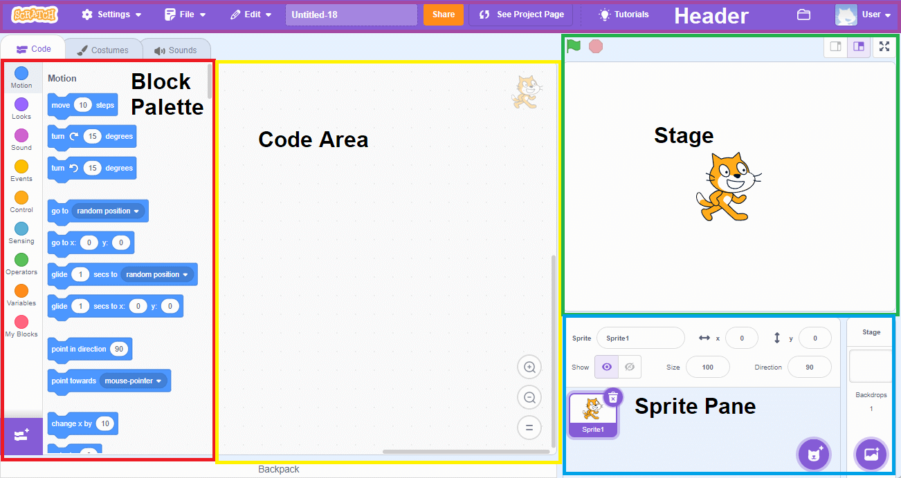
- Stage (Your Dashboard): The screen where your work comes to life. Think of it as a display board or a chart area that shows you the final results of your instructions.
- Sprites (Your Data Objects): The items on the screen that hold, track, and change information. In data science, we call these objects or variables.
- Blocks Palette (Your Data Toolbox): A menu of colorful blocks. Each block is a tool—some do math, some ask questions, and others store items in lists.
- Code Area (Your Data Pipeline): This is your assembly line. You snap blocks together here to create a clean pipeline of instructions that tells your data exactly what to do from start to finish.

